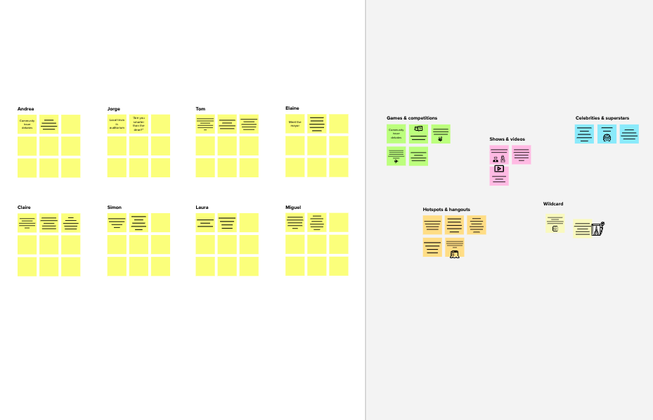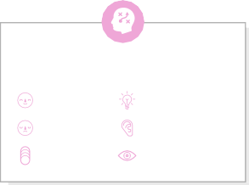

# Brainstorm

**TIP**

You can select a sticky noteand hit the pencil [switch tosketch]icontostartdrawing!

## Beforeyoucollaborate

Alittlebitofpreparationgoesalongwaywith this session. Here’s what you needtodotogetgoing.

**10minutes**

**1**

## Defineyourproblemstatement

What problem are you trying to solve? Frame yourproblemasaHowMightWestatement.Thiswillbethefocusofyourbrainstorm.

**5minutes**

**2**

## Brainstorm

Writedownanyideasthatcometomindthataddressyourproblemstatement.

**10minutes**

**3**

## Groupideas

Taketurnssharingyourideaswhileclusteringsimilarorrelatednotesasyougo.Onceallsticky notes have been grouped, give each cluster a sentence-like label. If a cluster isbiggerthansixstickynotes,tryandseeifyouandbreakitupintosmallersub-groups.

**20 minutes**

**4**

## Prioritize

Yourteamshouldallbeonthesamepageaboutwhat'simportantmoving forward. Place your ideas on this grid to determine whichideasareimportantandwhicharefeasible.

**20 minutes**

## Afteryoucollaborate

Youcanexportthemuralasanimageorpdftosharewithmembersofyourcompanywhomightfindithelpful.

**Quickadd-ons**

# &ideaprioritization

**PROBLEM**

**How might we [yourproblemstatement]?**

**A Teamgathering**

Definewhoshouldparticipateinthesessionandsendan

M PRAKASH

**TIP**

Add customizable tags to stickynotes to make it easier to find,browse, organize, andcategorize important ideas asthemeswithinyourmural.

P PRAKASH

L SAKTHIVEL

**D VIGNESH**

1. **Sharethemural**

Use this template in your ownbrainstormingsessionssoyourteamcan unleash their imagination andstart shaping concepts even if you'renotsittinginthesameroom.

invite.Sharerelevantinformationorpre-workahead.

1. **Setthegoal**

Think aboutthe problemyou'll befocusing onsolving inthebrainstormingsession.

1. **Learnhowtousethefacilitationtools**

UsetheFacilitationSuperpowerstorunahappyand

It sectormakes bankefficient andhelpful

end to endbanking andfinanceprocesses

it helps moreunderstanding

bankingoperationsin fastereasier

updateprocessingautomatically

moresecureway

Regulatoryandcompliance

Reducedoperational

bettercustomerexperience

Costs andrisks

Improvedinvestmentevaluation

Improvedloan andfacilityevaluation

Implementingthe properalgorithm

Relevantcost

Expensive

Bigexpensivemodelinitiality

AI for thefinancialindustry

Nocreativity

It increasingly collaboratingwith financial technology

Digitaltechnology isalmostimpactingindustry

AI extractingand organizingdataathand

Personalized financeguidance

Customersatisfaction

InteractivevoiceResponsesystem

**Shareaviewlink**tothemuralwithstakeholderstokeepthemintheloopabouttheoutcomesofthesession.

**B Exportthemural**

Export a copy of the mural as a PNG or PDF to attach toemails,includeinslides,orsaveinyourdrive.

**10minutes**toprepare

**1hour**tocollaborate

**2-8people**recommended

productivesession.

[**Openarticle**](https://support.mural.co/en/articles/2113740-facilitation-superpowers)

### Keyrulesofbrainstorming

Torunansmoothandproductivesession

### Keepmovingforward

**Strategyblueprint**

Define the components of a new idea orstrategy.

[**Openthe template**](https://app.mural.co/template/e95f612a-f72a-4772-bc48-545aaa04e0c9/984865a6-0a96-4472-a48d-47639307b3ca)

**Customerexperiencejourneymap**

Stay in topic.Deferjudgment.

Encourage wild ideas.Listentoothers.

### Importance

Ifeachofthese

Understand customer needs, motivations, andobstaclesforanexperience.

[**Openthe template**](https://app.mural.co/template/b7114010-3a67-4d63-a51d-6f2cedc9633f/c1b465ab-57af-4624-8faf-ebb312edc0eb)

Goforvolume. Ifpossible,bevisual.

taskscouldget

done without anydifficulty or cost,which would havethemostpositiveimpact?

**Strengths,weaknesses,opportunities&threats**

Identify strengths, weaknesses, opportunities,andthreats(SWOT)todevelopaplan.

|  |  |
| --- | --- |
|  |  |
|  |  |

[**Openthe template**](https://app.mural.co/template/6a062671-89ee-4b76-9409-2603d8b098be/ca270343-1d54-4952-9d8c-fbc303ffd0f2)

**TIP**

Participants can use theircursors to point at wheresticky notes should go onthe grid. The facilitator canconfirm the spot by usingthe laser pointer holding the**Hkey**onthekeyboard.

[**Sharetemplatefeedback**](https://muralco.typeform.com/to/CiqaHVat?typeform-source=app.mural.co)

[**Sharetemplatefeedback**](https://muralco.typeform.com/to/CiqaHVat?typeform-source=app.mural.co)

### Feasibility

Regardlessoftheirimportance,whichtasksaremorefeasiblethanothers?(Cost,time,effort,complexity,etc.)

**Template**

**Need someinspiration?**

See a finished versionof this template tokickstartyourwork.

[**Openexample**](https://app.mural.co/template/e5a93b7b-49f2-48c9-afd7-a635d860eba6/93f1b98d-b2d2-4695-8e85-7e9c0d2fd9b9)